# Prep for class

1. Create space between stimulus and response
2. [Load Canvas in browser](https://uth.instructure.com/courses/51972)
3. [Load Socrative in Browser](https://b.socrative.com/login/teacher/)
4. Load PowerPoint

# 00:00 Get settled

1. Press the record button
2. Go over miscellaneous items
3. Explain confidence intervals from last week

# 

# 00:20 Lab warm-up

1. [Navigate to Socrative](https://www.socrative.com/)
2. Publish lab warm-up on Canvas

# 01:15 Lab assignment

1. Placeholder

# 02:50 Adjourn

# Other Notes:

# Confidence intervals:

## Dr. Lee’s slide

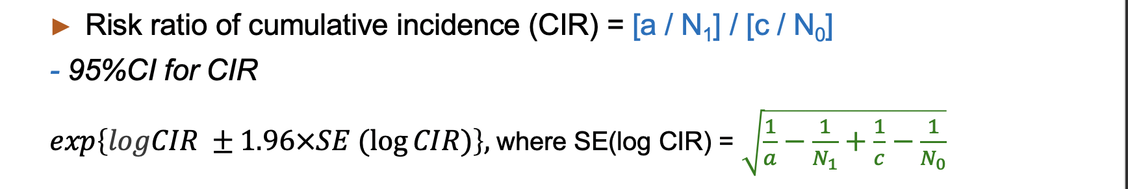

## Szklo & Nieto

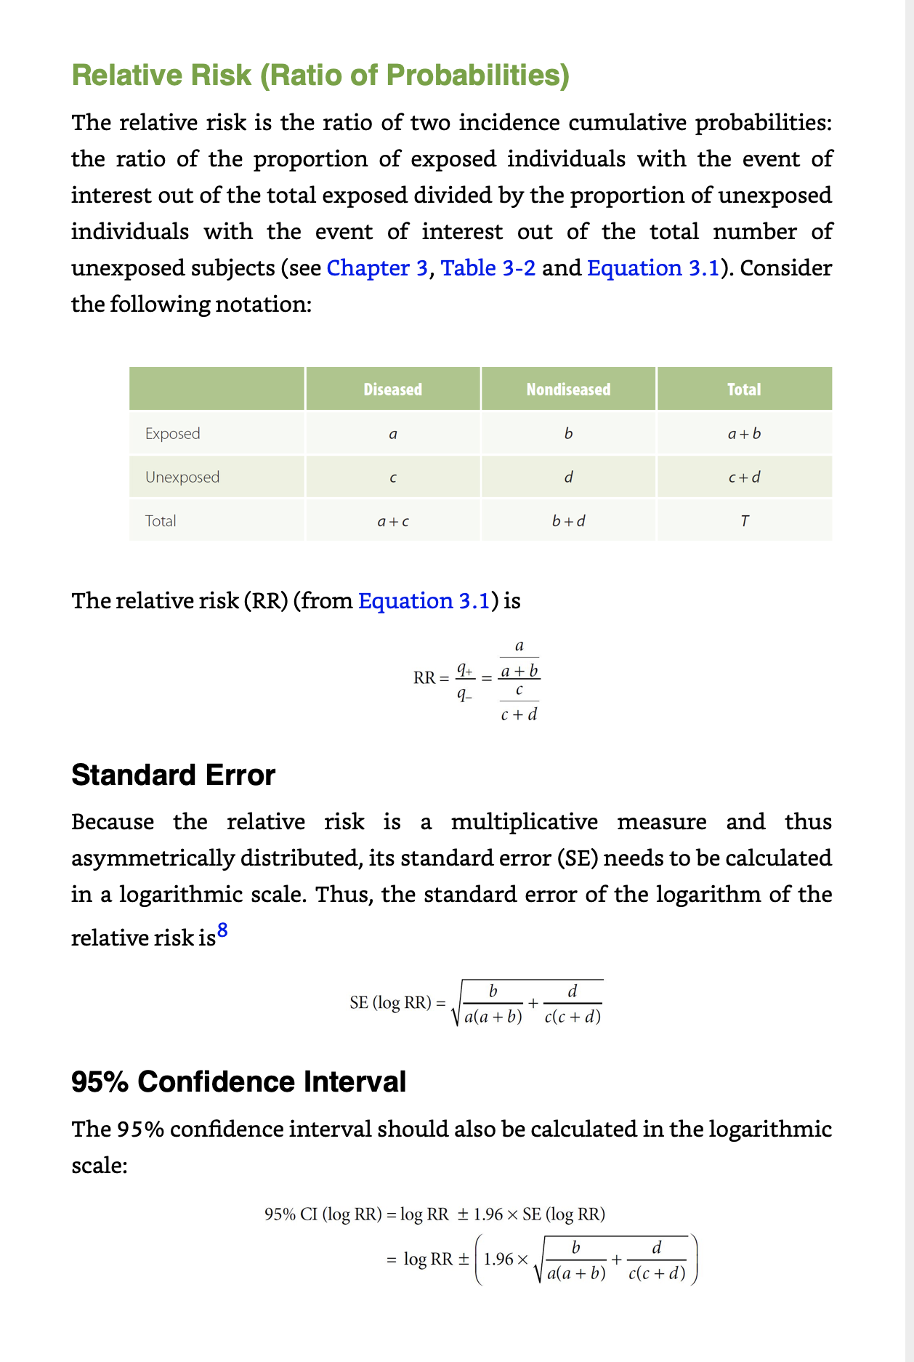

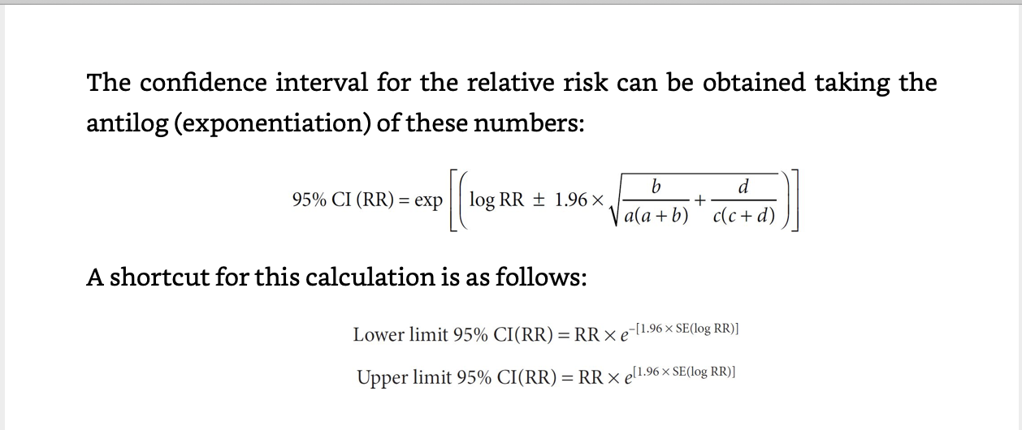

## My solution on the lab (Szklo’s shortcut):

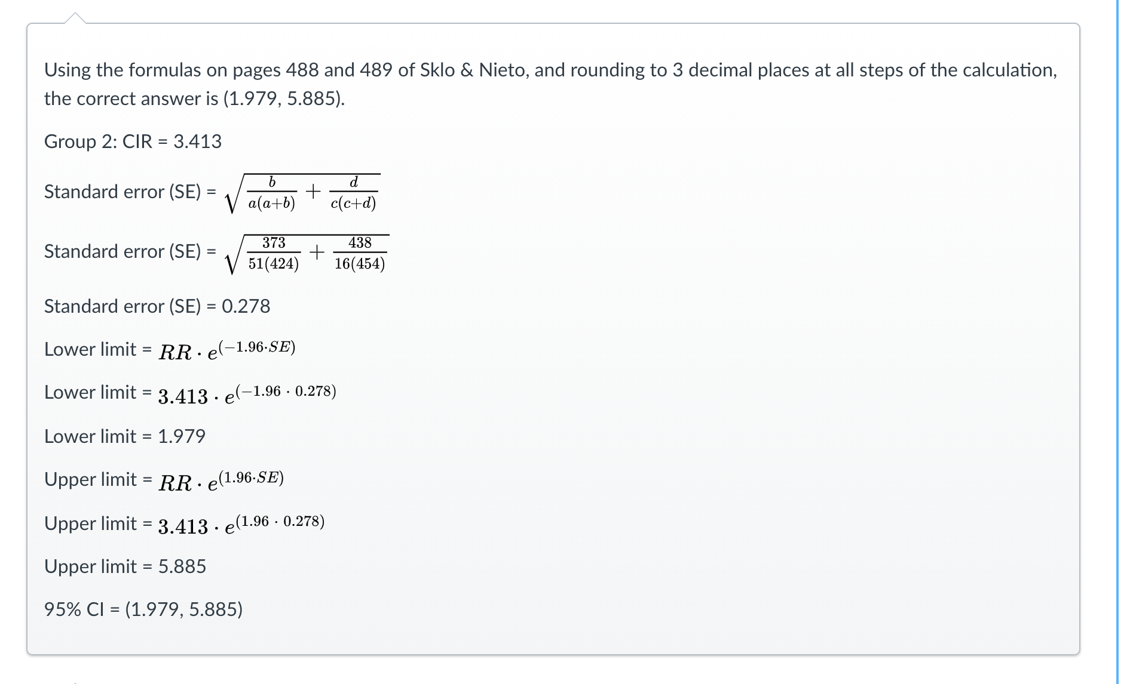

## Transformation of the SE formula:

=

=

[Same answers](https://docs.google.com/spreadsheets/d/1qi1097X2naVp2SoRrgEy-huAHpd7fNA5ClEFfmn9Ys4/edit#gid=1598247463)